# 

**National Level Development Bank Industry**

*As of Q3 published for FY 2081/82*



Prepared By:

Research Department

Sanima Capital Limited

*sanimacapital@sanimabank.com*

# Industry summery of Development Banks (National Level)

## PE vs PB Scatter Plot as of Q3 Report

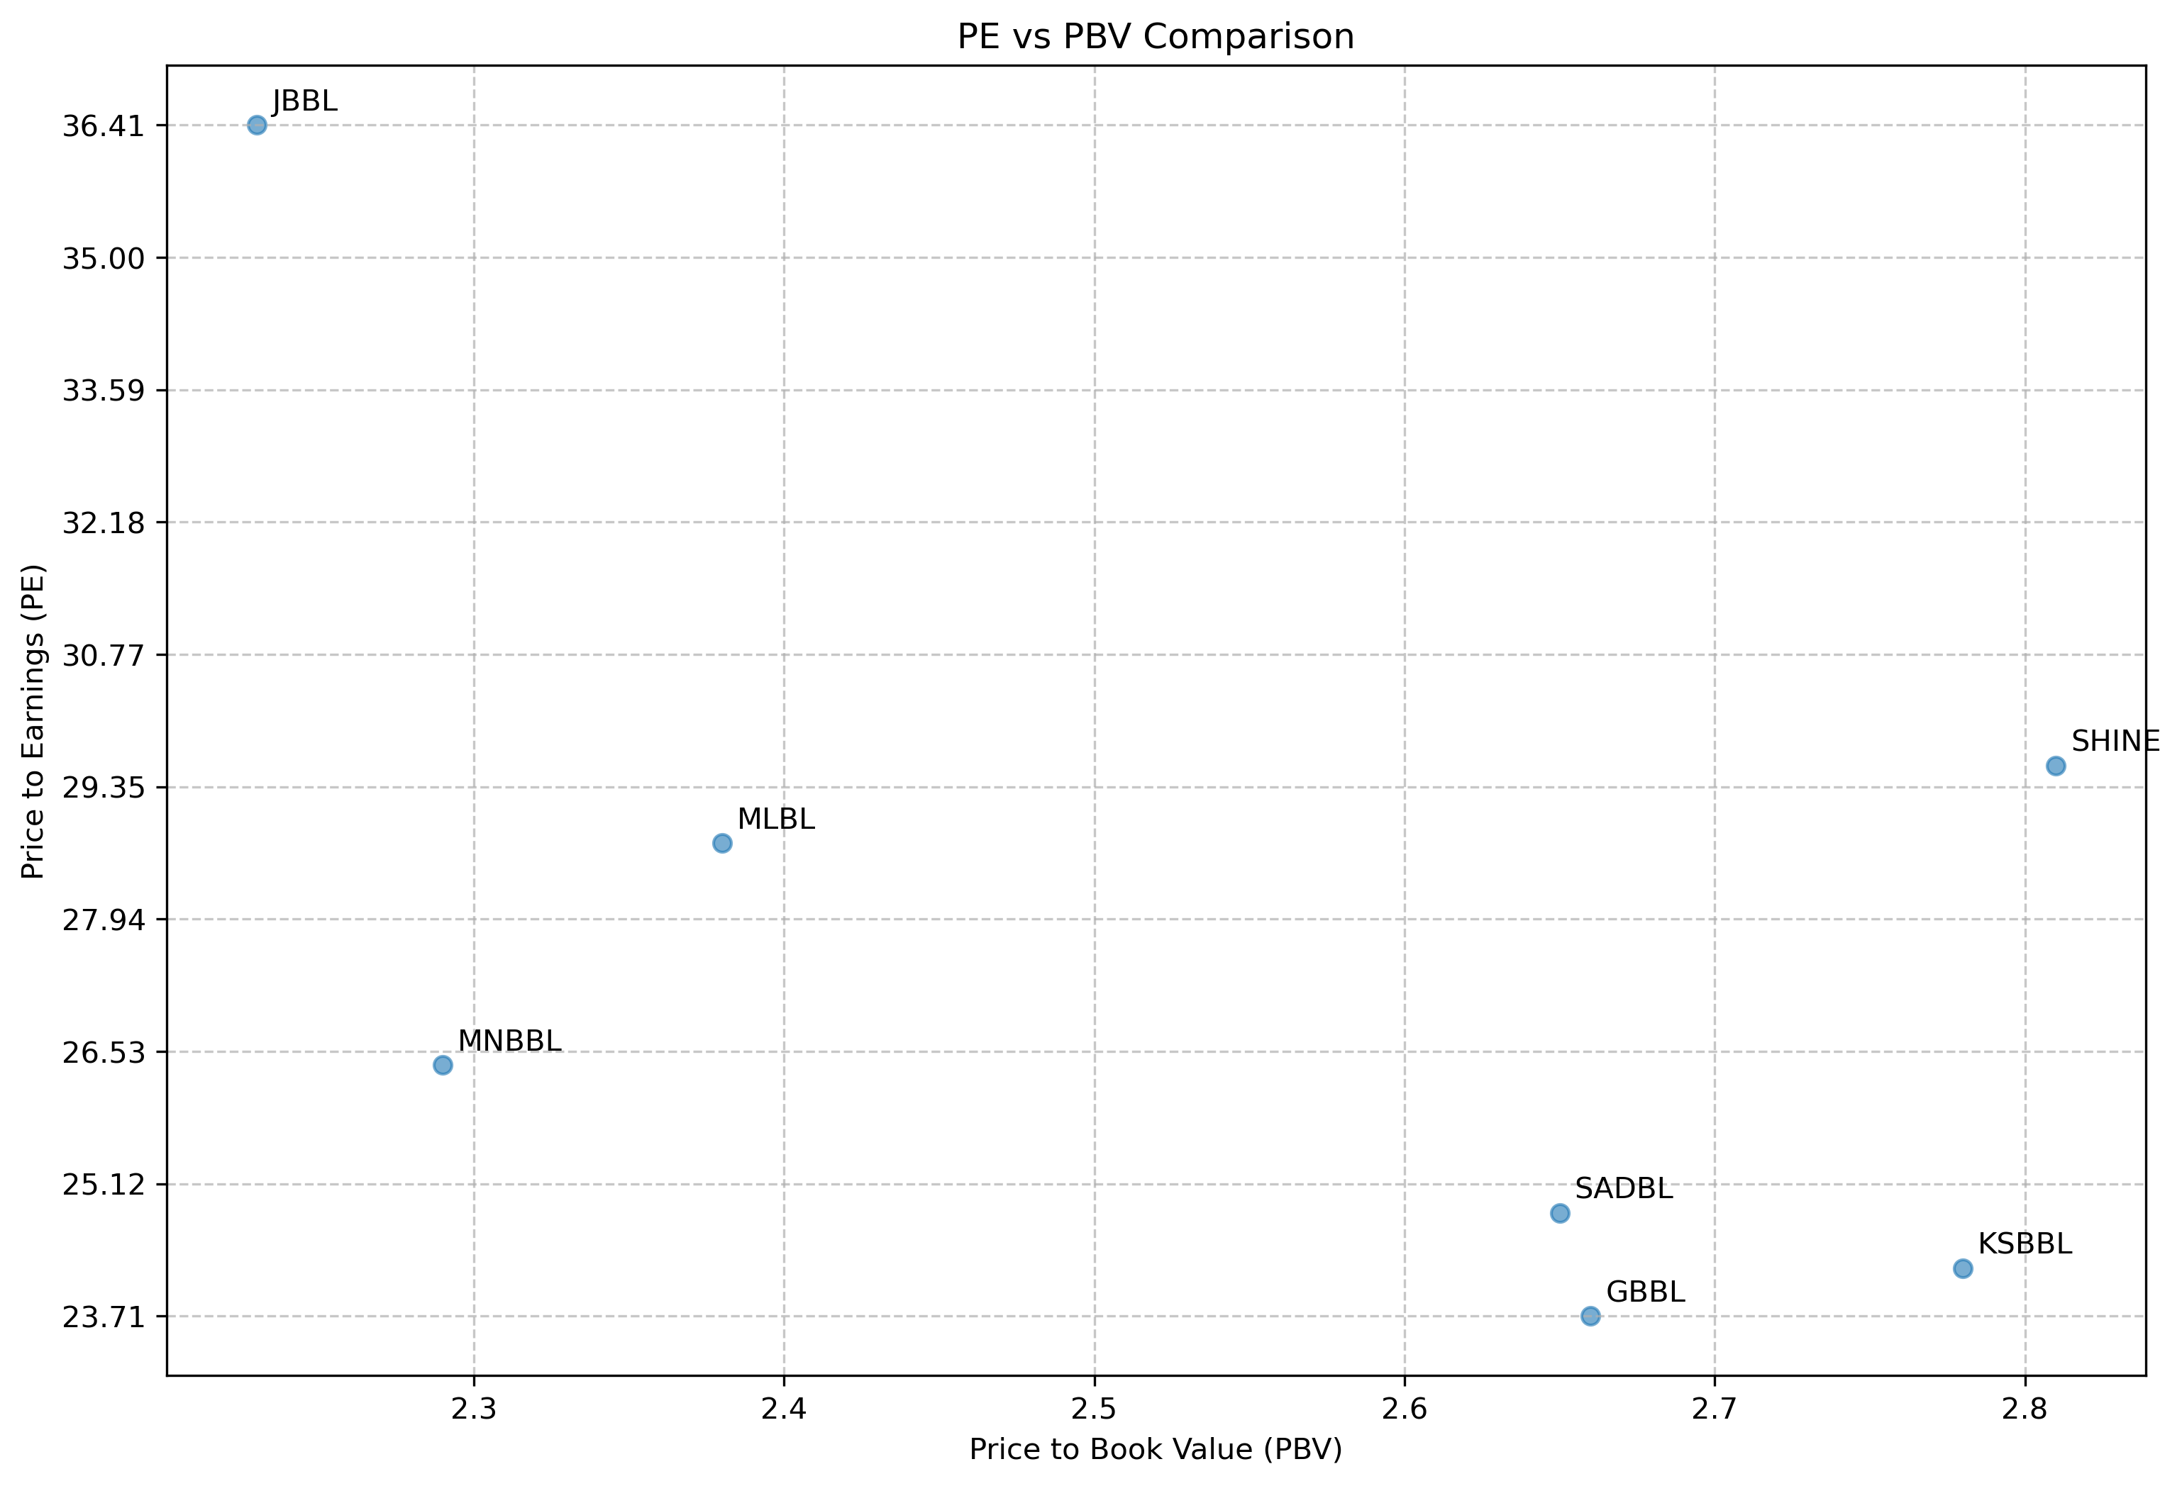

The scatter plot is a useful way to quickly compare development banks in terms of how the market values their earnings and assets. By examining the P/E and P/B ratios together, we can better understand market expectations, identify undervalued opportunities, or confirm strong growth investments. Each quadrant or position in the scatter plot reflects different investment appeals, from growth to value to balanced approaches.

**Analysis of NPL**

|  |  |  |
| --- | --- | --- |
| ABB | Non-Performing Loan (NPL) to Total Loan 2024/25Q3 | Non-Performing Loan (NPL) to Total Loan 2023/24Q3 |
| KSBBL | 4.27% | 3.55% |
| SHINE | 4.76% | 3.41% |
| GBBL | 4.78% | 2.97% |
| SADBL | 4.97% | 3.84% |
| LBBL | 7.18% | 3.69% |
| MLBL | 4.99% | 4.16% |
| MNBBL | 4.41% | 2.02% |
| JBBL | 4.98% | 4.97% |

As of December 2024, Karnali Development Bank faced significant financial challenges. The Nepal Rastra Bank (NRB) declared it a "crisis-ridden" institution due to several critical issues mostly due to non-performing loan (NPL) ratio of 40.85%. Due to which the report of the KRDBL is not included in the analysis.

The development banking sector of Nepal is experiencing a concerning deterioration in asset quality, with Non-Performing Loan (NPL) ratios increasing significantly across the board. Development banks showed NPL ratio increases, with LBBL exhibiting the most severe deterioration (from 3.69% to 7.18%, a 94.58% increase) and now holding the highest NPL ratio in the sector. MNBBL, despite maintaining a below-average NPL ratio of 4.41%, recorded the largest percentage increase at 118.32%. Only JBBL showed relative stability with a negligible 0.20% increase in its NPL ratio.

**ROE vs ROA Analysis**

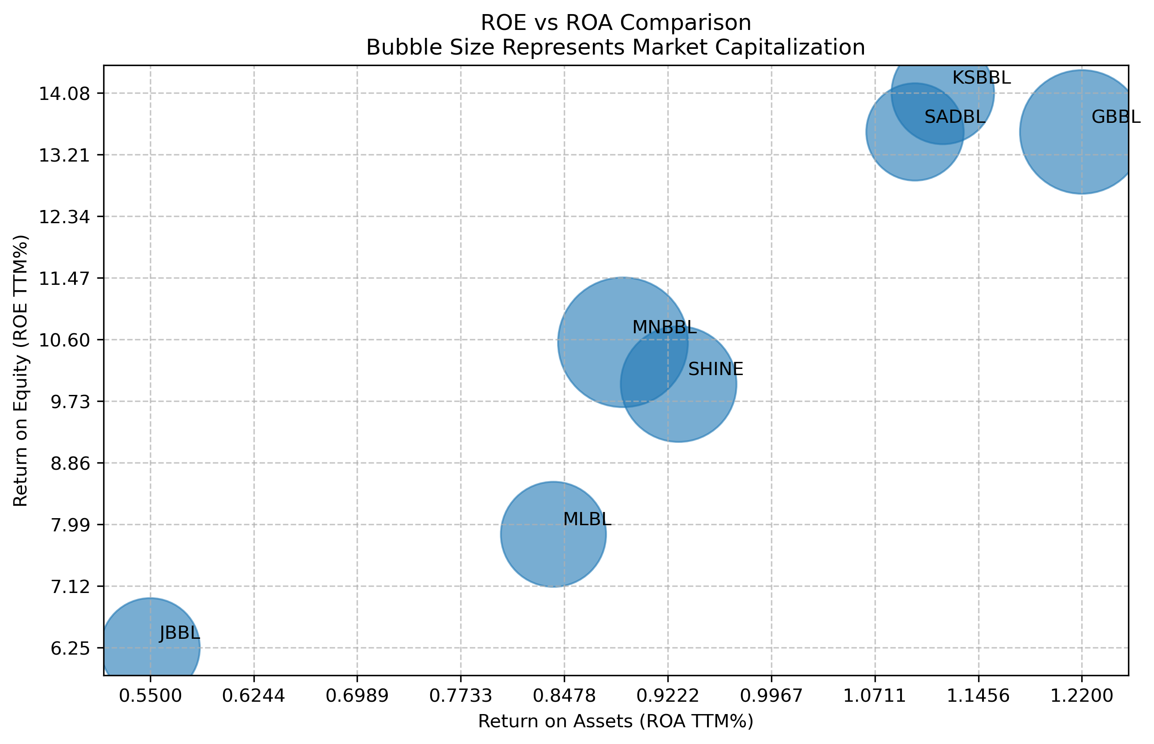

This visualization compares banks using three key financial metrics: Return on Assets (ROA)(TTM) on the x-axis shows how well banks use their assets to generate income, Return on Equity (ROE)(TTM) on the y-axis indicates profitability from shareholders' perspective, and bubble size represents each bank's market capitalization. The combination of these metrics provides a comprehensive view of bank performance, where higher ROA indicates better asset utilization, higher ROE suggests stronger returns for shareholders, and bubble size gives context about the bank's relative market value.

The analysis reveals a clear distinction in bank performance, with GBBL, KSBBL, and SADBL emerging as top performers due to their strong Return on Assets (ROA) and Return on Equity (ROE), suggesting efficient operations and competitive market positions that make them potentially attractive investment options.

|  |  |  |  |  |  |  |  |  |  |
| --- | --- | --- | --- | --- | --- | --- | --- | --- | --- |
| ABB | DDPS (Q3 Total) | DDPS (Q3 as per report Annualized | ICPS (Q3) adjusted to tax | EPS as of Q32024/25 | EPS as of Q32023/24 | BVPS | Price | Price/Earnings | Price/BvPS |
| GBBL | 6.17 | 8.23 | 7.94 | 17.2 | 16.0 | 153.5 | 408.13 | 23.71 | 2.66 |
| KSBBL | 14.24 | 18.98 | 5.69 | 18.7 | 12.6 | 163.2 | 453.71 | 24.22 | 2.78 |
| SADBL | 6.76 | 9.01 | (4.53) | 16.3 | 10.1 | 152.6 | 403.94 | 24.81 | 2.65 |
| MNBBL | 8.79 | 8.04 | 11.03 | 13.7 | 16.5 | 158.3 | 362 | 26.39 | 2.29 |
| MLBL | 3.81 | 5.07 | 3.79 | 13.5 | 11.6 | 163.9 | 389.45 | 28.75 | 2.38 |
| SHINE | 7.94 | 10.59 | (8.75) | 14.1 | 14.1 | 147.8 | 415.74 | 29.58 | 2.81 |
| JBBL | (12.94) | (17.25) | 7.48 | 9.3 | 4.6 | 151.9 | 338.66 | 36.41 | 2.23 |
| LBBL | 2.61 | 0.02 | 16.50 | 1.8 | 12.6 | 180.2 | 409.87 | 223.75 | 2.27 |

A significant valuation gap exists across the sector, with P/E ratios ranging from 23.71 to 223.75. LBBL presents an outlier with the highest P/E ratio of 223.75 having the lowest EPS of only 1.8, LBBL's severe earnings decrease (-85.71% YoY) and high P/E ratio (223.75x), alongside substantial impairment charges (NPR 16.50 per share), suggesting significant asset quality challenges. GBBL, KSBBL, and SADBL offer the most attractive P/E ratios (23.71x, 24.22x, and 24.81x respectively), significantly below the sector average. KSBBL leads with the highest earnings per share (NPR 18.7) and impressive YoY growth of 48.41%, while also offering the sector's most attractive dividend yield at 4.18%. J

ICPS (Impairment Charges Per Share) indicates the per-share non-annualized impact of impairment costs on the bank's profitability. High impairment charges can signal riskier assets or potential credit quality issues. The Q3 ICPS data reveals significant variations in credit risk management across banks. The sector shows an average impairment charge per share (ICPS) of NPR 4.89, though this figure masks extreme divergence between institutions. Six banks report positive impairment charges (indicating additional loan loss provisions), while two banks (SADBL and SHINE) report negative impairment charges (suggesting provision reversals or recoveries). LBBL demonstrates the most concerning metrics with an extraordinarily high ICPS of NPR 16.50, representing 916.67% of its current EPS. This aligns with its high NPL ratio of 7.18%.

**Dividend history analysis**

|  |  |  |  |  |  |  |  |  |
| --- | --- | --- | --- | --- | --- | --- | --- | --- |
| Company Name | Bonus (%) 2077-78 | Cash (%) 2077-78 | Bonus (%) 2078-79 | Cash (%) 2078-79 | Bonus (%) 2079-80 | Cash (%) 2079-80 | Bonus (%) 2080-81 | Cash (%) 2080-81 |
| GBBL | 16.00 | 0.00 | 13.00 | 1.50 | 9.50 | 0.50 |  | 5.00 |
| JBBL | 11.00 | 4.50 | 3.00 | 3.80 |  |  |  |  |
| KSBBL | 18.50 | 0.97 | 4.41 | 0.23 |  |  | 7.00 | 5.00 |
| LBBL | 13.00 | 0.68 | 3.00 | 9.00 | 4.00 | 4.50 | 3.00 | 4.00 |
| MLBL | 20.00 | 1.05 | 4.00 | 6.47 |  | 6.40 | 3.00 | 4.00 |
| MNBBL | 17.57 | 0.93 | 13.50 | 0.71 | 9.75 | 0.51 |  |  |
| SADBL | 10.00 | 0.53 | 8.53 | 0.45 | 5.00 | 0.26 | 3.65 | 0.19 |
| SHINE | 10.93 | 0.57 | 13.30 | 0.70 | 10.50 | 0.55 | 3.00 | 5.00 |

## Dividend announcement as till date as of 02- 10-2025

|  |  |  |  |  |  |
| --- | --- | --- | --- | --- | --- |
| Symbol | Bonus (%) | Cash (%) | Total (%) | Announcement Date | Book Closure Date |
| [GBBL](https://www.sharesansar.com/company/gbbl) |  | 5.00 | 5.00 | 2024-12-20 | 2025-01-02 [Closed] |
| [LBBL](https://www.sharesansar.com/company/lbbl) | 3.00 | 4.00 | 7.00 | 2024-12-20 | 2025-01-03 [Closed] |
| [SADBL](https://www.sharesansar.com/company/sadbl) | 3.65 | 0.19 | 3.84 | 2024-12-18 | 2025-01-01 [Closed] |
| [MLBL](https://www.sharesansar.com/company/mlbl) | 3.00 | 4.00 | 7.00 | 2024-12-16 | 2024-12-31 [Closed] |
| [SHINE](https://www.sharesansar.com/company/shine) | 3.00 | 5.00 | 8.00 | 2024-11-10 | 2024-12-18 [Closed] |
| [KSBBL](https://www.sharesansar.com/company/ksbbl) | 7.00 | 5.00 | 12.00 | 2024-09-13 | 2024-10-01 [Closed] |

**GBBL, KSBBL, SHINE** consistently provide dividends, reflecting strong financial stability and a commitment to shareholder returns. **LBBL, MLBL, SADBL** are consistent with moderate payouts. **JBBL** and **MNBBL** stand out as the only banks without any declared dividends for this year.

## NRB reported summery

|  |  |  |  |  |  |  |  |  |  |
| --- | --- | --- | --- | --- | --- | --- | --- | --- | --- |
| Abb | Tier 1 Capital To RWA | Capital Fund to RWA | Non-Performing Loan (NPL) to Total Loan | Total Loan Loss Provision to Total NPL | Credit Deposit Ratio as per NRB Calculations | Cost of Funds | Net Interest Spread | Base Rate | Base rate - COF |
| MLBL | 12.31% | 15.75% | 4.99% | 101.90% | 87.41% | 5.04% | 4.29% | 7.20% | 2.16% |
| JBBL | 8.53% | 12.72% | 4.98% | 145.66% | 83.81% | 5.37% | 4.01% | 7.51% | 2.14% |
| MNBBL | 10.19% | 12.36% | 4.41% | 90.92% | 87.46% | 5.31% | 4.59% | 7.42% | 2.11% |
| SADBL | 10.57% | 13.70% | 4.97% | 85.88% | 83.75% | 5.39% | 4.04% | 7.45% | 2.06% |
| KSBBL | 10.14% | 12.86% | 4.27% | 104.64% | 86.07% | 5.41% | 4.30% | 7.42% | 2.01% |
| SHINE | 11.24% | 12.59% | 4.76% | 82.83% | 82.40% | 5.09% | 4.34% | 6.99% | 1.90% |
| GBBL | 10.98% | 13.09% | 4.78% | 111.06% | 87.95% | 5.07% | 4.56% | 6.92% | 1.85% |
| LBBL | 9.46% | 12.94% | 7.18% | 78.46% | 87.14% | 5.83% | 4.34% | 7.36% | 1.53% |

## Capital Adequacy

The sector maintains healthy capital buffers with an average Tier 1 capital ratio of 10.43% and total capital fund to RWA of 13.25%, well above regulatory minimums. MLBL leads with the strongest Tier 1 position (12.31%), followed by SHINE (11.24%) and GBBL (10.98%). Only JBBL shows concerning capital levels with a Tier 1 ratio of 8.53%, significantly below sector average though still compliant with regulatory requirements i.e. 8.5%. JBBL will have harder time to increase the business growth due to the lower Tier 1 capital growth.

## Profitability Metrics

Net interest spreads average 4.31% across the sector, with MNBBL (4.59%) and GBBL (4.56%) delivering the strongest margins. After adjusting for NPL impact, MNBBL maintains leadership with a risk-adjusted spread of 4.39%. LBBL shows the least efficient funding structure with the highest cost of funds (5.83% vs. sector average of 5.31%) and smallest base rate-to-cost differential (1.53%). GBBL demonstrates superior interest rate management with competitive rates (base rate of 6.92%) while maintaining healthy spreads.

## Liquidity and Regulatory Compliance

All banks maintain adequate liquidity positions and comply with regulatory requirements. The sector's average credit-deposit ratio of 85.75% suggests prudent liquidity management, though GBBL, MNBBL, MLBL, and LBBL show more aggressive lending relative to their deposit base, approaching the 90% regulatory threshold.

## Overall Risk Assessment

Based on a composite risk evaluation, KSBBL emerges as the most balanced institution with moderate risk metrics across all categories. LBBL presents the highest risk profile, combining capital weakness, poor asset quality, inadequate provisioning, and high funding costs. GBBL demonstrates the strongest overall fundamentals with robust capital, adequate provisioning, strong spreads, and efficient pricing.

## Growth Analysis

|  |  |  |  |  |  |  |  |  |
| --- | --- | --- | --- | --- | --- | --- | --- | --- |
| ABB | LOANS 2024/25Q3 | LOANS 2023/24Q3 | Growth | Loan amount (in billion) | DEPOSITS 2024/25Q3 | DEPOSITS 2023/24Q3 | Growth | Deposit amount (in billion) |
| KSBBL | 52,404,695 | 48,611,606 | 7.8% | 3.79 | 61,887,395 | 57,271,053 | 8.1% | 4.62 |
| GBBL | 73,778,197 | 69,346,584 | 6.4% | 4.43 | 85,786,910 | 82,827,015 | 3.6% | 2.96 |
| SHINE | 56,044,353 | 53,437,300 | 4.9% | 2.61 | 69,084,126 | 62,776,430 | 10.0% | 6.31 |
| SADBL | 46,894,693 | 44,879,675 | 4.5% | 2.02 | 54,789,519 | 52,659,016 | 4.0% | 2.13 |
| LBBL | 47,877,881 | 46,473,590 | 3.0% | 1.40 | 56,925,249 | 57,764,906 | -1.5% | (0.84) |
| MNBBL | 97,933,545 | 95,168,381 | 2.9% | 2.77 | 113,330,953 | 110,405,509 | 2.6% | 2.93 |
| MLBL | 46,130,173 | 44,891,235 | 2.8% | 1.24 | 53,203,643 | 53,063,479 | 0.3% | 0.14 |
| JBBL | 47,796,166 | 53,896,753 | -11.3% | (6.10) | 58,752,819 | 63,425,432 | -7.4% | (4.67) |

The table and chart show the loan and deposit growth for different development banks from Q3 of 2022/23 to Q3 of 2024/25.

**KSBB, GBBL** and **SHINE** show robust growth in both loans and deposits, suggesting financial stability and market confidence. **GBBL** demonstrates strong deposit growth, increasing liquidity. **JBBL** and **LBBL** experienced declines in loan growth, JBBL may further need to decrease the loan due the near Tire1 CAR.

**Change in Net Interest Income (NII)**

|  |  |  |  |  |  |  |
| --- | --- | --- | --- | --- | --- | --- |
| ABB | YOY% Growth | Net Interest Income (Data in Billions) | | | | |
| 2024/25 | 2024/25 | 2024/25 | 2023/24 | 2023/24 |
|  |  | Q3 | Q2 | Q1 | Q4 | Q3 |
| SHINE | 18.4% | 0.63 | 0.64 | 0.66 | 0.62 | 0.59 |
| KSBBL | 14.1% | 0.57 | 0.57 | 0.52 | 0.67 | 0.50 |
| GBBL | 6.0% | 0.83 | 0.86 | 0.99 | 0.95 | 0.71 |
| LBBL | 5.8% | 0.43 | 0.47 | 0.46 | 0.53 | 0.42 |
| MNBBL | 5.0% | 1.09 | 1.08 | 1.11 | 1.05 | 1.04 |
| MLBL | 3.8% | 0.52 | 0.54 | 0.48 | 0.45 | 0.59 |
| SADBL | -1.3% | 0.51 | 0.37 | 0.55 | 0.43 | 0.50 |
| JBBL | -7.2% | 0.46 | 0.54 | 0.57 | 0.66 | 0.58 |

This table provides Year-Over-Year (YOY) growth of Net Interest Income (NII) and NII for various quarters over the last five quarter NII is key and core income for the banks hence it is very important to analyze the NII.

## Change in Net Profit (Loss)

|  |  |  |  |  |  |  |
| --- | --- | --- | --- | --- | --- | --- |
| ABB | YOY%  Growth | Net Profit/Loss as per profit or loss (Data in Billions) | | | | |
| 2024/25 | 2024/25 | 2024/25 | 2023/24 | 2023/24 |
|  |  | Q3 | Q2 | Q1 | Q4 | Q3 |
| SHINE | -0.1% | 0.18 | 0.09 | 0.24 | 0.18 | 0.14 |
| KSBBL | 48.8% | 0.17 | 0.15 | 0.17 | 0.27 | 0.07 |
| GBBL | 7.3% | 0.18 | 0.32 | 0.23 | 0.45 | 0.17 |
| LBBL | -85.5% | (0.10) | (0.05) | 0.20 | 0.26 | 0.13 |
| MNBBL | -16.9% | 0.22 | 0.22 | 0.28 | 0.41 | 0.45 |
| MLBL | 16.9% | 0.15 | 0.19 | 0.09 | 0.10 | 0.10 |
| SADBL | 61.2% | 0.24 | 0.14 | 0.06 | 0.25 | 0.17 |
| JBBL | 101.1% | 0.06 | 0.10 | 0.15 | 0.09 | 0.05 |

Table provides Year-Over-Year (YOY) growth of Net Profit and Net profit for various quarters over the last five quarter NII.

**CASA composition of the Development Bank**

|  |  |  |  |  |  |  |  |  |
| --- | --- | --- | --- | --- | --- | --- | --- | --- |
| Abb | Year | Qtr | Current Deposits % | Savings Deposits % | Fixed Deposits % | Call Deposits % | Others Deposits % | Current + Savings+ Call |
| LBBL | 2024/25 | Feb-Mar | 2.10% | 26.99% | 63.42% | 7.45% | 0.04% | 36.54% |
| SADBL | 2024/25 | Feb-Mar | 1.37% | 27.53% | 63.77% | 7.29% | 0.04% | 36.19% |
| KSBBL | 2024/25 | Feb-Mar | 2.04% | 30.08% | 61.73% | 6.15% | 0.00% | 38.27% |
| SHINE | 2024/25 | Feb-Mar | 1.30% | 38.75% | 55.68% | 4.24% | 0.02% | 44.29% |
| GBBL | 2024/25 | Feb-Mar | 1.74% | 39.20% | 50.23% | 8.79% | 0.04% | 49.73% |
| MNBBL | 2024/25 | Feb-Mar | 2.19% | 35.94% | 56.10% | 5.68% | 0.08% | 43.82% |
| JBBL | 2024/25 | Feb-Mar | 2.13% | 42.65% | 46.46% | 8.63% | 0.13% | 53.41% |
| MLBL | 2024/25 | Feb-Mar | 2.50% | 45.83% | 43.61% | 7.19% | 0.87% | 55.52% |

The table provides a breakdown of deposit types (Current, Savings, Fixed, Call, and Others) as percentages of total deposits for each bank, along with a combined percentage for Current, Savings, and Call deposits.

Cost-Efficient Funding: MLBL leads in CASA composition (55.52%), indicating a strong reliance on low-cost deposits, which can enhance profitability. SHINE and GBBL have a healthy CASA ratio, striking a balance between low-cost deposits and fixed deposits.

Higher Costs. SADBL's reliance on fixed deposits (63.42%) increases funding costs, potentially impacting its net interest margin. LBBL's low CASA ratio (36.54%) reflects limited low-cost deposits, which may pressure profitability**.**

**Conclusion**

The performance of Nepal's national-level development banks reflects a mixed scenario with some banks demonstrating strong financial and operational efficiency, while others face challenges in profitability, asset quality, and funding strategies. Banks like KSBBL, MNBBL and GBBL stand out for their robust loan and deposit growth, high CASA ratios, and consistent dividend payouts, indicating stable financial health and operational effectiveness.

The regulatory metrics indicate that most banks maintain adequate capital adequacy ratios, but JBBL's high non-performing loans (4.98%) and declining profitability highlight significant credit risk. LBBL presents the most concerning risk profile across multiple dimensions: highest NPL ratio (7.18%), severely decreased earnings and aggressive impairment charges

KSBBL Presents the strongest investment case with sector-leading asset quality (4.27% NPL), robust earnings growth (48.41% YoY), attractive valuation (P/E 24.22x), and strong dividend yield (4.18%). Similarly, MNBBL, GBBL and SHINE should be kept in watchlist.

**Disclaimer:**

* *This report is based on publicly available data and is intended for informational purposes only. Any decision made based on this report are solely at the viewer discretion.*